Olatunde W Jolaosho

Algorithms & SKLearn

Tech Talent Academy HLT

4th April 2022.

1. **What is Linear Regression?**

Linear Regression is a type of model that is used to estimate the relationship between an independent and dependent variable using a straight line. We use one variable to predict the other.

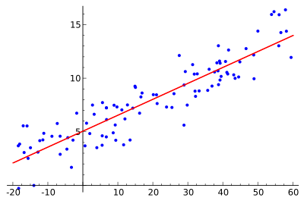

**Is it Supervised/Unsupervised/Reinforcement learning?**

Linear regression is a supervised machine learning because its model finds the best fit linear line between the two variables.

**What does the algorithm do?**

This type of algorithm is used for predictive analysis. It does this by getting the best value of the two variables to get the best fit line

**In which situations will it be most useful?**

We will use linear regression to evaluate trends and make estimates and predictions.

**Can you find any examples of where this algorithm has been used**?

If the sales of a product increase steadily over a long period of time, a linear regression analysis would be used to forecast the product sales in the future months.

1. **What is Logistic regression?**

Logistic regression is a statistical analysis method used in predicting a binary outcome, for instance, a yes or no outcome, and based on prior observations of a data set. Unlike linear regression, logistics help predicts a dependent variable by analyzing the relationship between one or more independent variables.

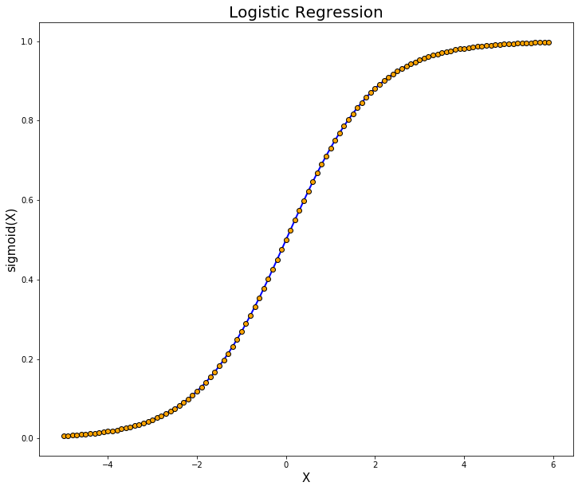

**Is it Supervised/Unsupervised/Reinforcement learning?**

Logistic regression is a supervised learning algorithm as it uses known labels for training. It is a model used to predict the probability of a yes or no occurrence.

**What does the algorithm do?**

This type of regression is used to analyze and conduct when the dependent variable is a binary one (0 and 1), take for example the probability of an event to take place, the probability of a team winning or not, etc

**In which situations will it be most useful?**

Logistic regression is most useful when a prediction is categorical that has to be a yes or no, or a true or false situation.

**Can you find any examples of where this algorithm has been used**?

This type of model or algorithm can be used to predict if a sports team will either win or lose a match. It has studied the outcome of the team based on prior observation and will help in predicting the outcome of a sporting event.

1. **What is KNN (K-Nearest Neighbours)?**

This is a type of learning model that is used to store all available cases and classify the new cases based on given similarity measures.

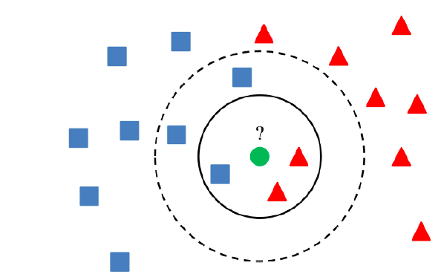

**Is it Supervised/Unsupervised/Reinforcement learning?**

This is also a supervised learning model used to train under supervision - training is done using labeled data that are available.

**What does the algorithm do?**

The KNN algorithm calculates the probability of the test data belonging to the classes of ‘K’ training data and the class that holds the highest probability will be selected

**In which situations will it be most useful?**

KNN can be used for applications that require high accuracy but do not require a human-readable model. The quality of prediction on this type of model depends on the distance measured.

**Can you find any examples of where this algorithm has been used?**

It is used to forecast and predict the price of stocks of a company base on performance measures and related economic factors.